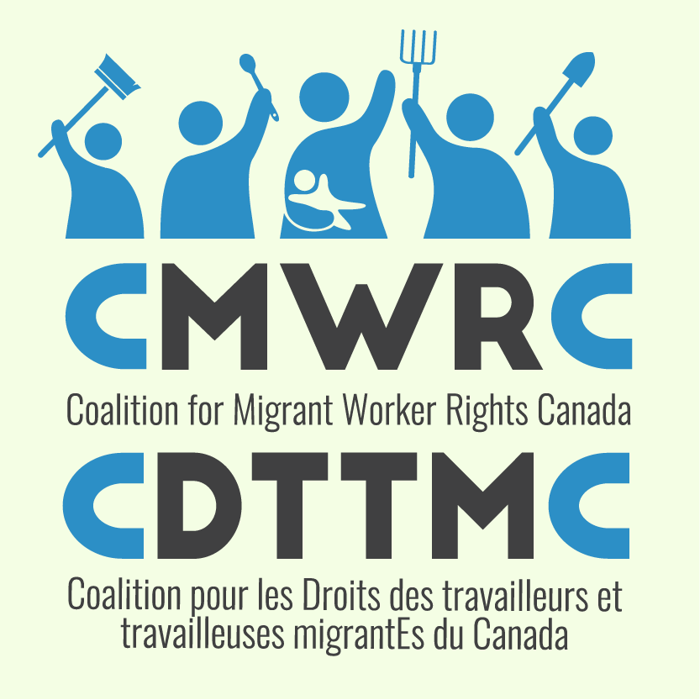
Letter to the Editor
Lots of people read the letters to the editor. Even if they are short, letters are a good way of reaching the public with our issues and concerns about migrant worker issues. They are a good way to encourage people to discuss issues and respond to them. Write often.

Tips for writing letters to the editor:
- Focus on one issue
- The best time to write a letter is when there is a news story about migrant worker issues already in the papers but right now we need as many stories as possible
- Keep it short – 100-200 words maximum – check your local newspaper for their word length.
- Use words and language that people easily understand
- Make sure it’s clear why you think this is an important issue
- Sign your name and give your address and a contact telephone number
- You can send letters by email
- You can find the letter to editor email address on the website of the newspapers. If you’re having trouble, get in touch with us and we will work with you to find it.

Sample Letter
Many people think that the main problem with the Temporary Foreign Workers Program (TFWP) is that there are too many foreign workers taking jobs from Canadians. Fact is there are less than 100,000 migrant workers and 1.3 million unemployed citizens. Blaming migrant workers for unemployment is a red herring.
There are real problems: Migrant workers are tied to their employer and can’t change jobs. Their families can’t visit them, and even those that have come back to Canada for forty years can’t live here permanently. The previous government made it harder for Caregivers to get permanent residence and took away paternity benefits from agricultural workers.
Right now the federal government is reviewing the Temporary Foreign Workers Program. It’s time to make things fair. That means permanent immigration status, open work permits and basic dignity for all. See www.migrantrights.ca for more.

First Name, Last Name
Address, City, Postal Code, Telephone Number

